Summary and Reflection Report
I have finished creating the mobile application for the customer and delivered the contact, task, and appointment services. This report provides a summary and reflection on the work done throughout the development process. I will discuss my unit testing approach for all three features and my experience writing Junit tests, the testing techniques that I used, and the mindset I had while creating and testing the application.
For the contact, task, and appointment features, I first reviewed the object requirements provided by the customer. I identified the required fields couldn’t hold null values, the length of the objects shouldn’t exceed a certain character length, that the ids should be unique, and that appointment dates could not be in the past. This approach was closely aligned with software requirements because each requirement was tested directly. When checking the objects worked properly, I would use assertEquals() to verify the data was being matched like it should. Example: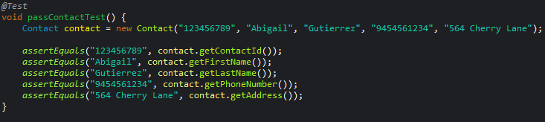
To make sure the invalid requirements were rejected. Like when the phone number should only be ten characters long, when ids needed to be unique, or when the objects should not be null. I would use assertThrows() to verify that an IllegalArgumentException was thrown when a required field was set to null, a certain length, or have a similar id.
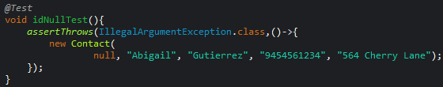
I knew my tests were effective because the coverage percentage showed that most of the application’s code was executed during testing. My overall coverage percentage was 89.4%, across all three features. This doesn’t mean I got all the bugs, but it does show most of the code was tested. I was confident that the customer requirements were covered during testing. By the way I developed the code I could make invalid and valid tests based on the customer requirements, verifying that the project behaved as expected.
The way I ensured my code was technically sound was by the Junit tests that I had run for my applications. I did one test at a time making sure I was getting all requirements. Example would be testing the id requirements when testing I used the requirements given and coverage analysis to make sure I was getting most of the tests needing to be done. By testing both valid and invalid inputs, I was able to verify that the application met the customer requirements.
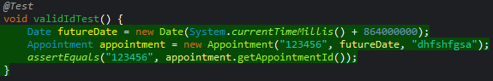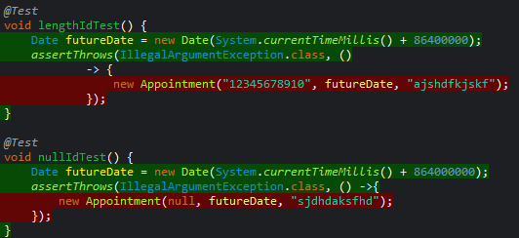
When picking the data structure for my program I did think of efficiency. I picked hash tables because it uses unique keys and is able to access data fast. This made the functions adding, deleting, and updating easier than looping through a whole array. The average time o(1) for inserting, searching, and deleting. This would make it faster than using a linked list like I had tried to use before.
My software testing techniques that I employed were reviewing requirements, unit testing, dynamic testing, and code coverage analysis. When starting off I would review what requirements were needed to be done a static technique. When testing my program, I used Junit testing this would help me to test and see if when I inserted data into an object the behavior would work as expected or not. This allowed me to test the requirements such as null values, character limits, unique ids, and functions. Then I would combine it with coverage analysis to see what areas of code I needed to test more thoroughly. Dynamic testing was used when I ran the code and observed what the behavior of the program would happen.
Some testing techniques I could have used were additional static and dynamic testing techniques. A static testing technique I did not use was peer reviews. If I would have worked with a partner while creating the code. We could have looked over each other’s work to catch bugs, logical or functional, and just help improve the tests or even the code. For dynamic testing I could have tested the code through the console and checked different inputs to see the outcomes.
All these techniques can be used in different software projects and situations. Junit testing is used in java projects this helps test classes and methods. This helps find bugs early and often while coding the software. Code coverage analysis testing helps developers create test cases to improve tests. This helps developers be able to be more confident about their work, not a guarantee of bug free but it is better. When working with a team, static techniques such as peer reviews can be very helpful. When developers work together this can help them be able to catch bugs, improve code, and make sure everyone knows and understands the requirements. Dynamic testing techniques like running code on console can help developers see the different outcomes/behaviors when running. Breakpoints and debuggers can help when examining code this will help developers scope out where the problem/ bug is.
While working on this application I would say my extent that I employed caution was high I wanted to ensure I tested everything. The reason it was important to understand the relationships between the classes and services is because a failure on one page can mess up the other page from working right. As if when I am making a field like a phone number it must be 10 characters. If I did not validate this requirement correctly, invalid phone numbers could be stored in the Contact object and then used by the ContactService. This could cause the application to behave incorrectly when adding, updating, or retrieving contacts. Because of this, I carefully tested both the classes and the service functions of all features to ensure they worked together correctly. To help limit the bias when reviewing my code, I would say using the coverage and the Junit test helped me be able to make sure I got a lot more tests done. The reason it is important to not cut corners when writing or testing code is because it can lead to company loss. Such as money or even people not liking the company. The way I plan to avoid technical debt would be to try to be careful and read what the requirements are carefully. Testing my code often throughout the development of it. Also making sure I remember to think about efficiency when writing the code.

